 | 

Al Imam Mohammad Ibn Saud Islamic University
College of Computer and Information Sciences
Computer Science Department

Course Title: | Software Security
Course Code: | CS442
Semester: | First Semester 2025-2026
Assignment | Assignment Buffer Overflow
Student Name: | Alshaimaa Alamer | Student ID: | 444000118

Task One: Modify exploit.py
First we turn of the randomization so that addresses remain stable otherwise I couldn't capture registers reliably or run the exploit.

“compile with -g (global) we know the distance”
changed its ownership to root and set chmod 4755 so it runs set-UID as root
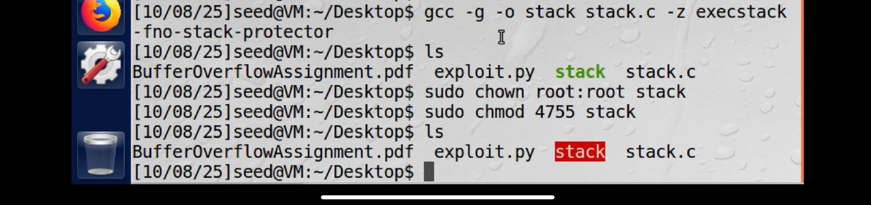
create the file badfile as the crafted input that will be used to trigger the buffer overflow during exploitation. 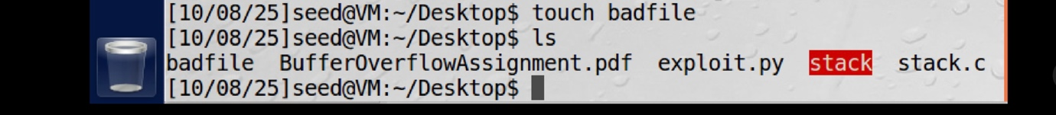

I launched GDB on the stack binary to load debug symbols
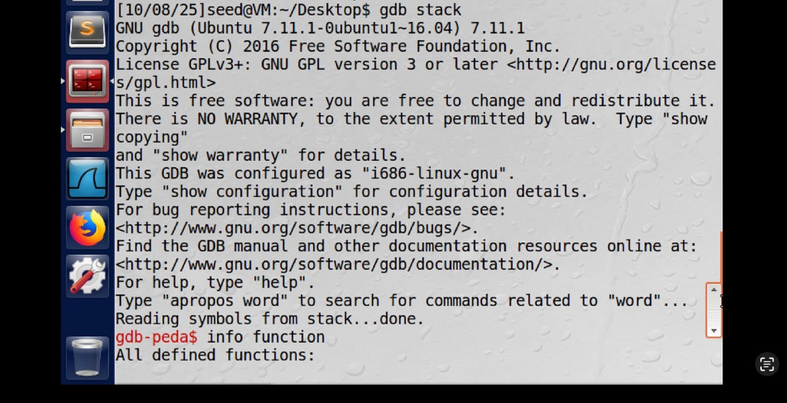
listed all defined functions and PLT symbols in GDB to locate foo
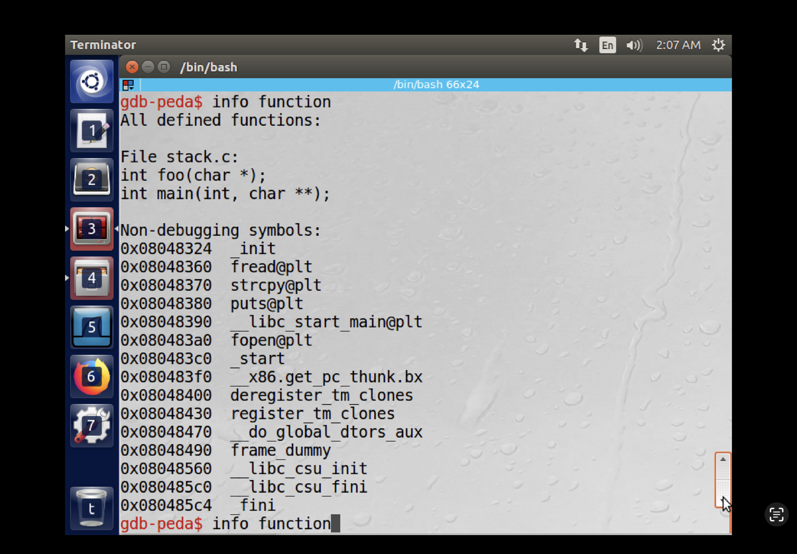

Set a breakpoint at foo.
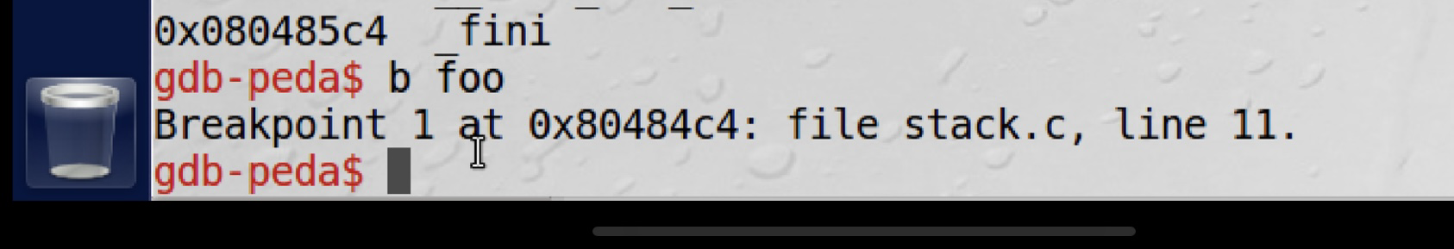

Run the program in GDB
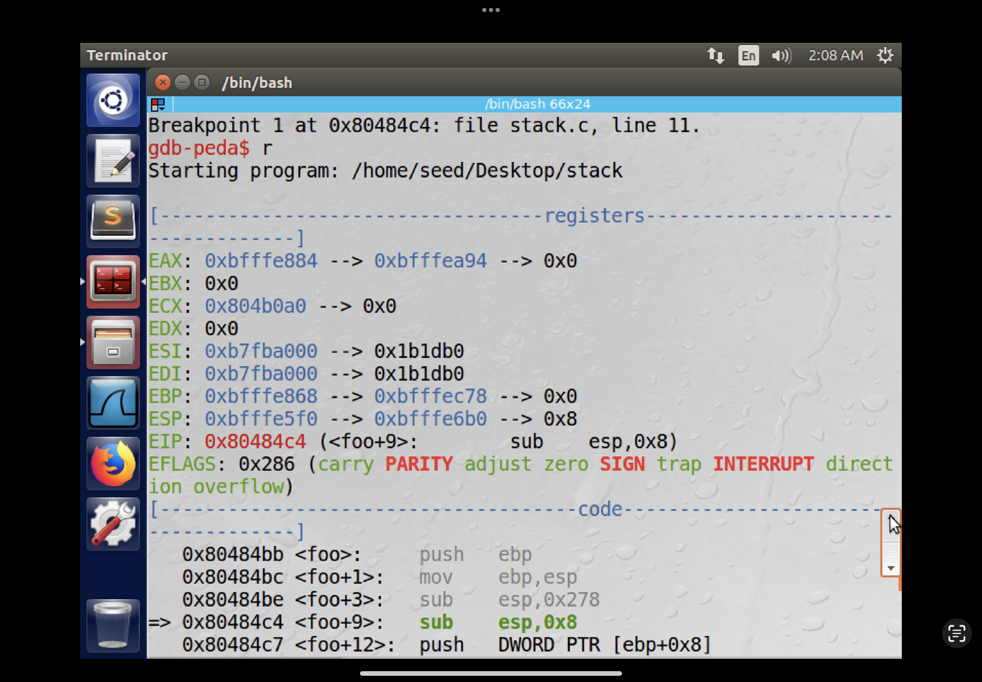
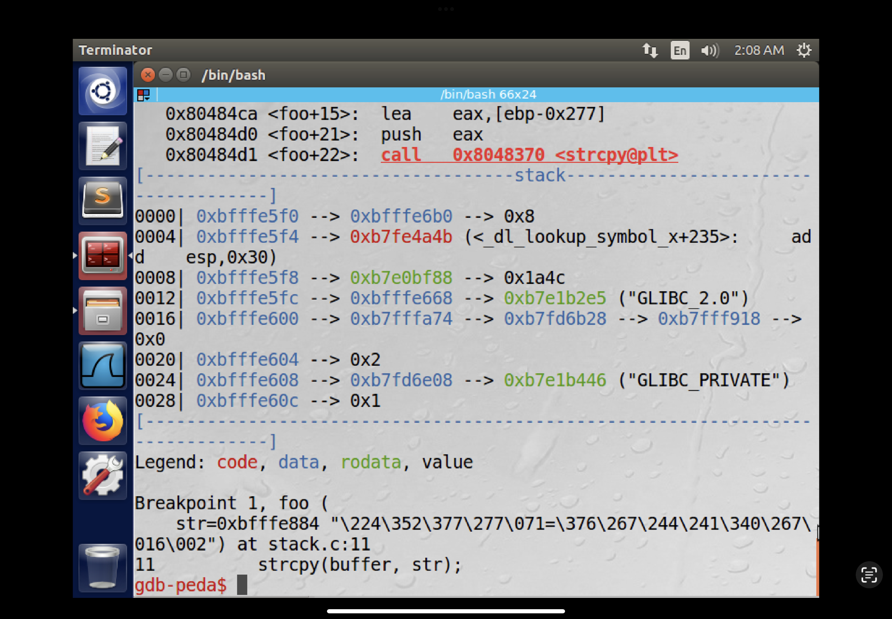

I printed the value of $ebp and &buffer
then calculated the distance between them (631 bytes) to find the buffer-to-return-address offset.
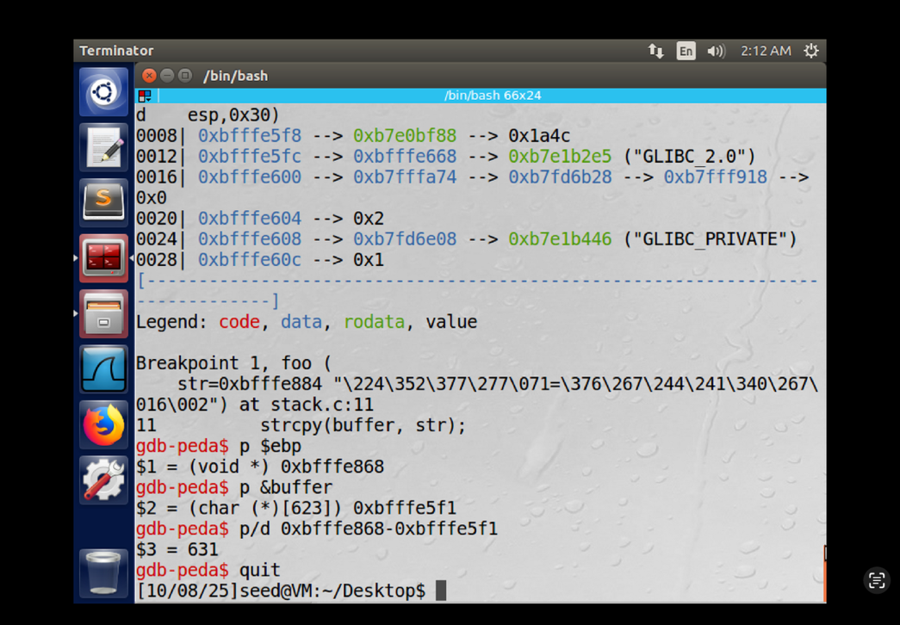

I wrote the crafted content to badfile to be used as input for the exploit

- I filled the content buffer with 850 NOPs (0x90) using
bytearray(0x90 for i in range(850)).
- placed the shellcode near the end of the buffer by
start = 850-len(shellcode)
- I added 120 to the return address to move it into the NOP-sled/shellcode area accounting for the stack layout so the pointer lands where the exploit can run.
Then wrote the little-endian return address into content[635:639]
“631 + 4 to target the saved return address”.

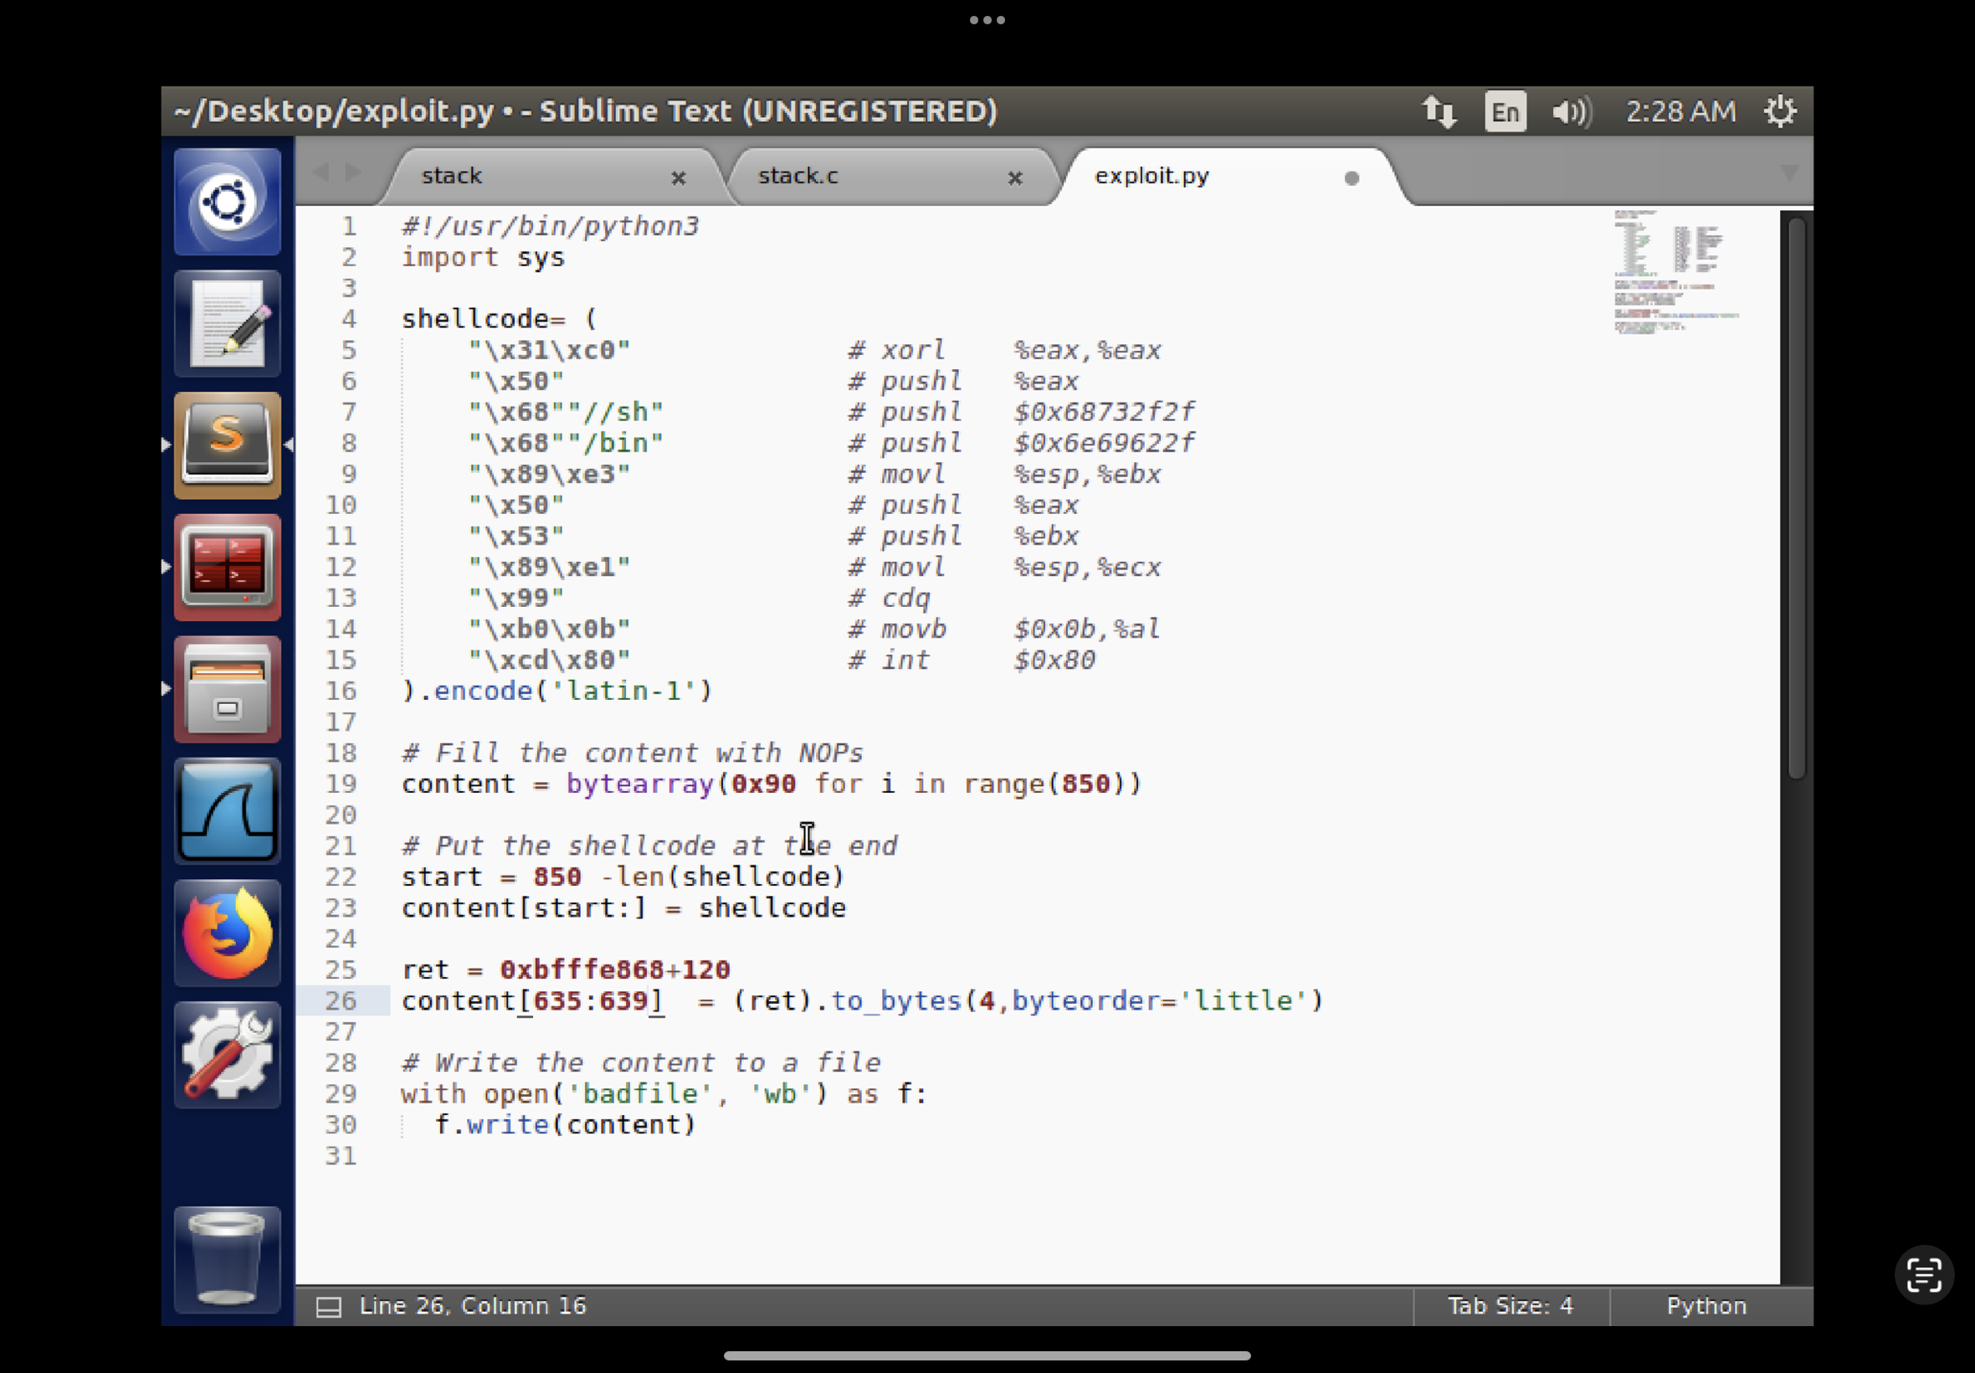

Removed the old badfile, made the script executable by (chmod u+x), and ran it to generate a new badfile.
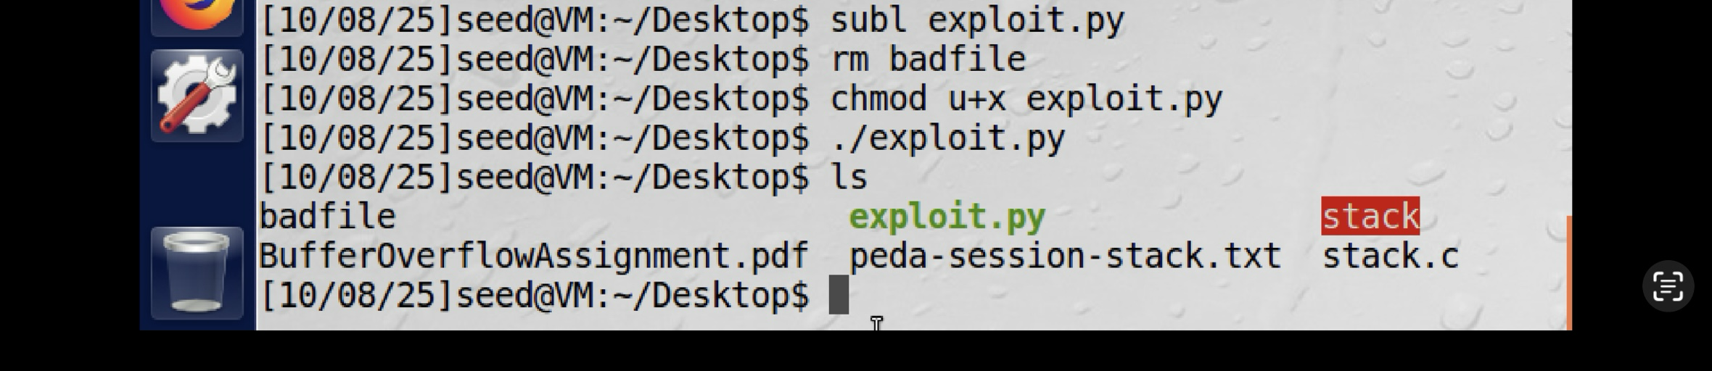

Compiled without -g, gave permissions, then ran ./stack and checked with id
(uid=1000 — user seed)
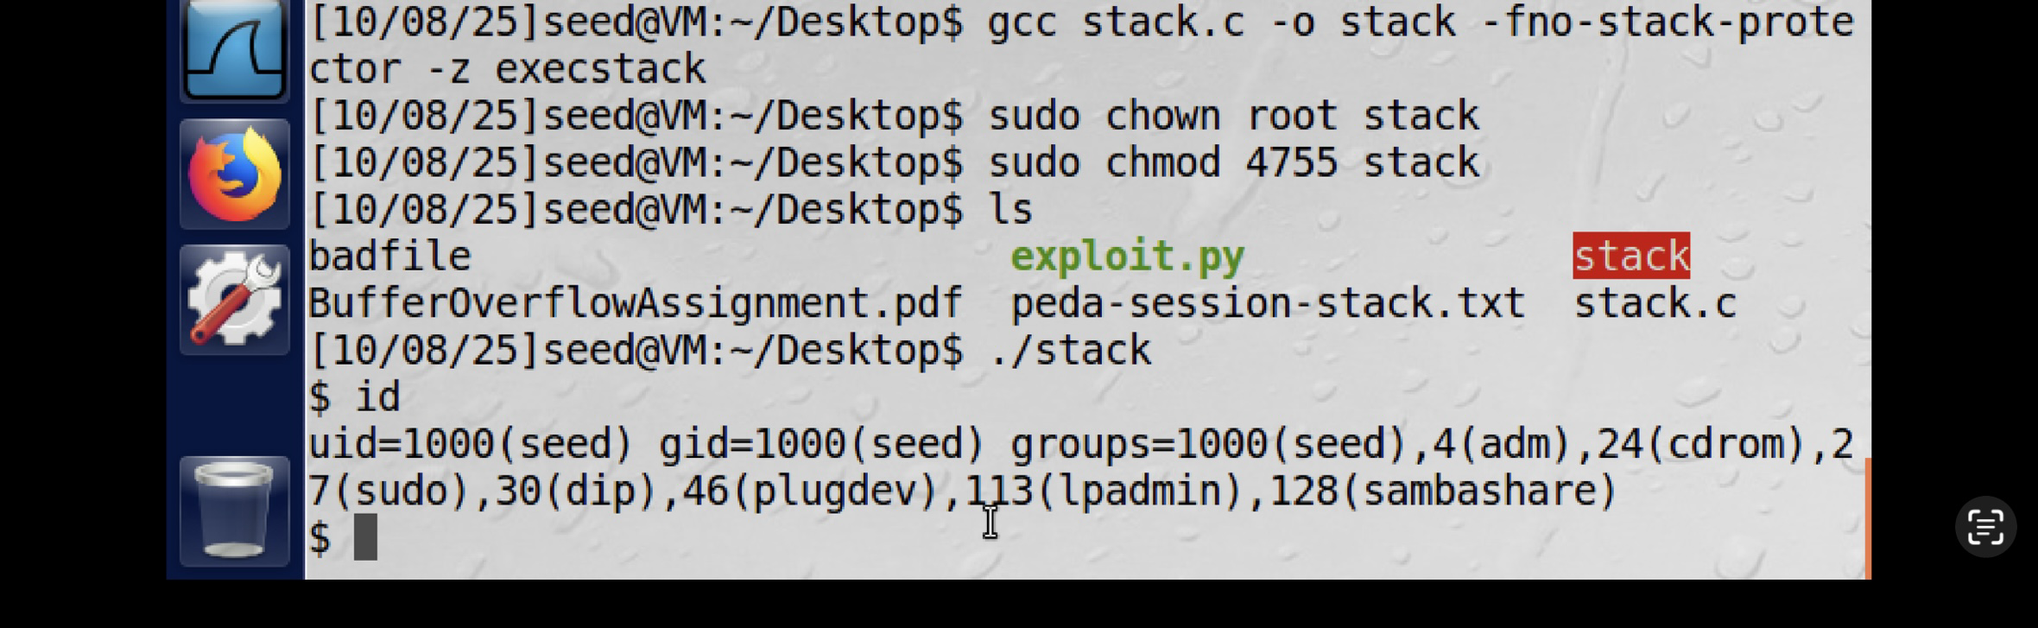

Task Two: obtain root sell

changed the shell string from /bin/sh to /bin/zsh to test spawning a zsh shell this requires updating the shellcode immediates and ensuring /bin/zsh exists on the target.
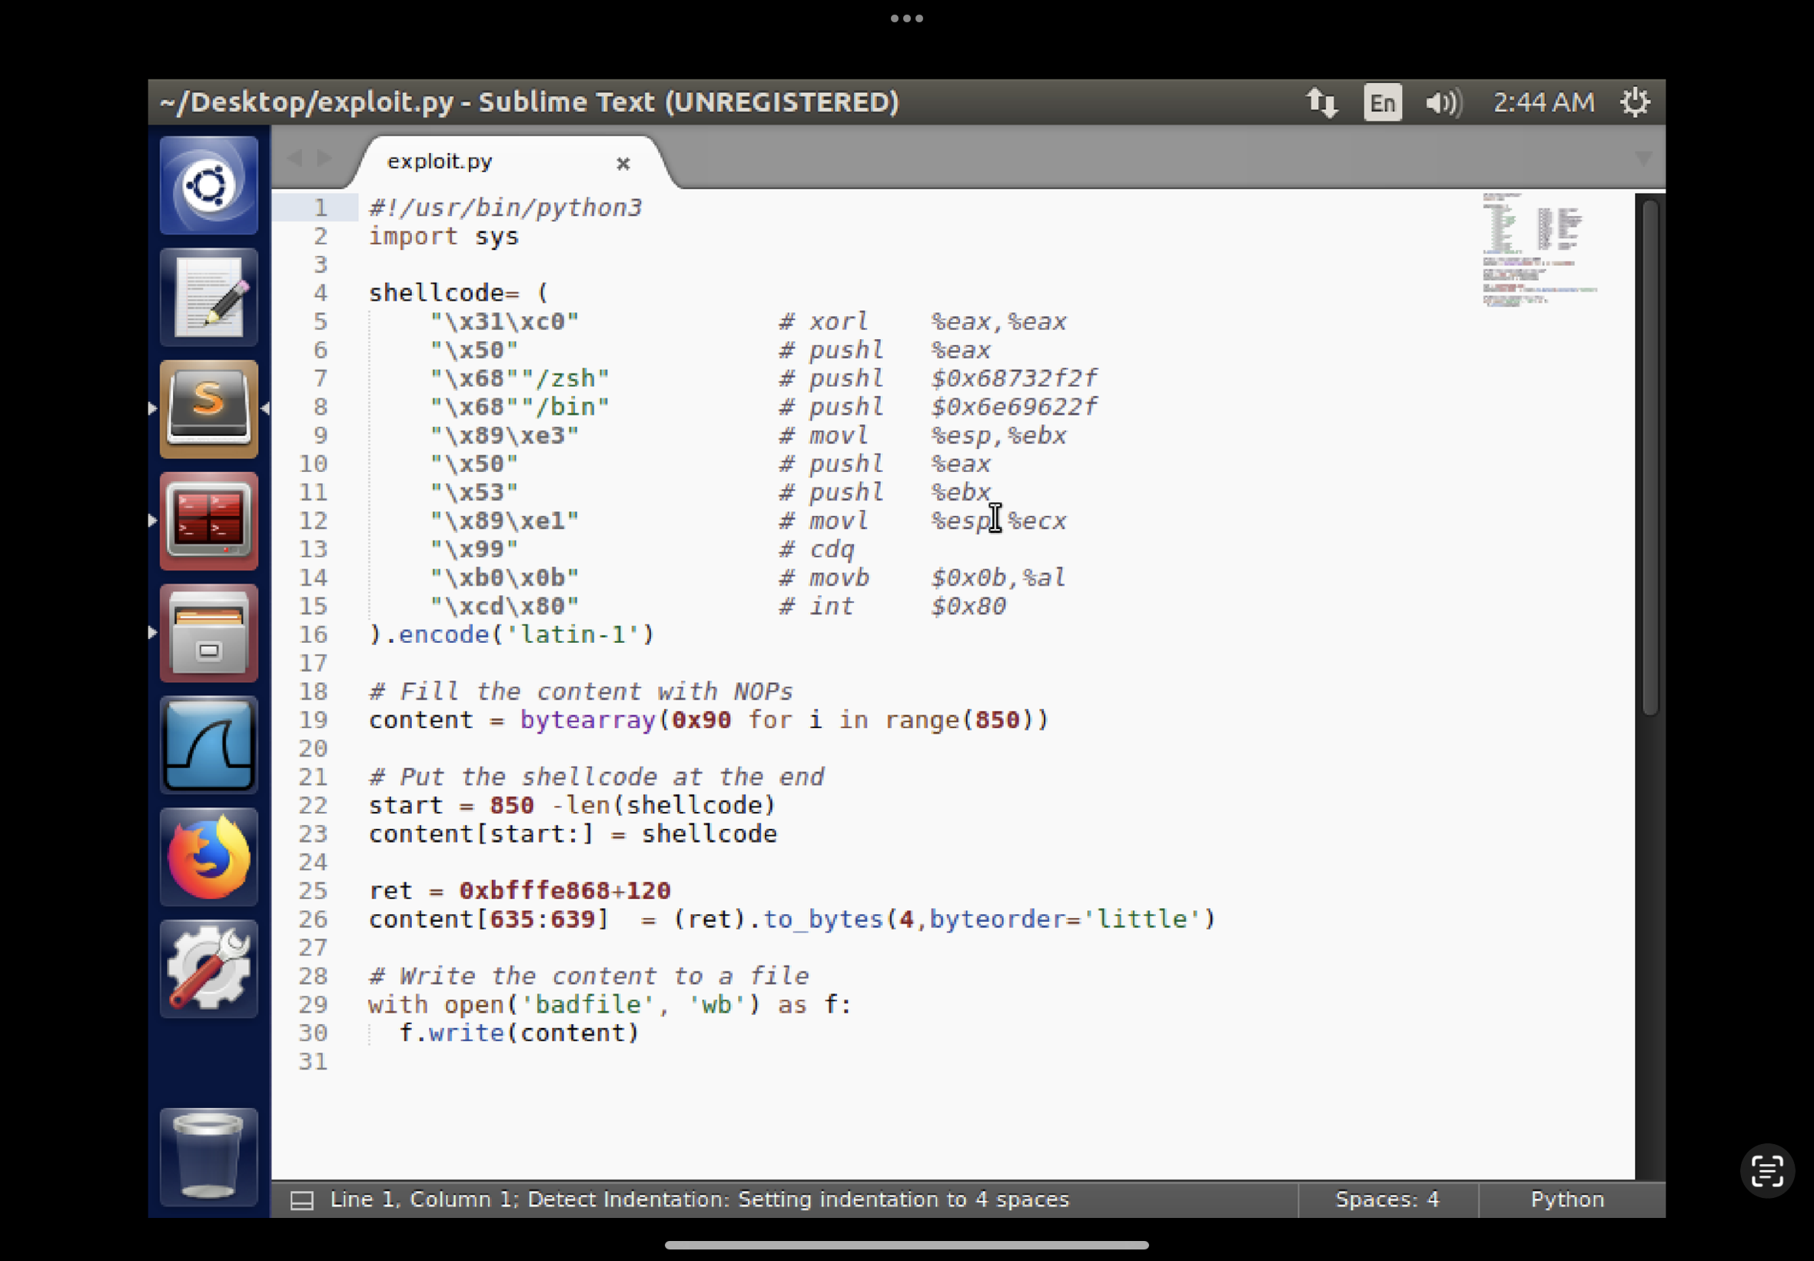

- Removed the old badfile, made exploit.py executable, and ran it to generate a new badfile.
- Compiled and gave the permissions
- then executed the program
- teste it with id an whoimi confirmed a root shell (euid=0).
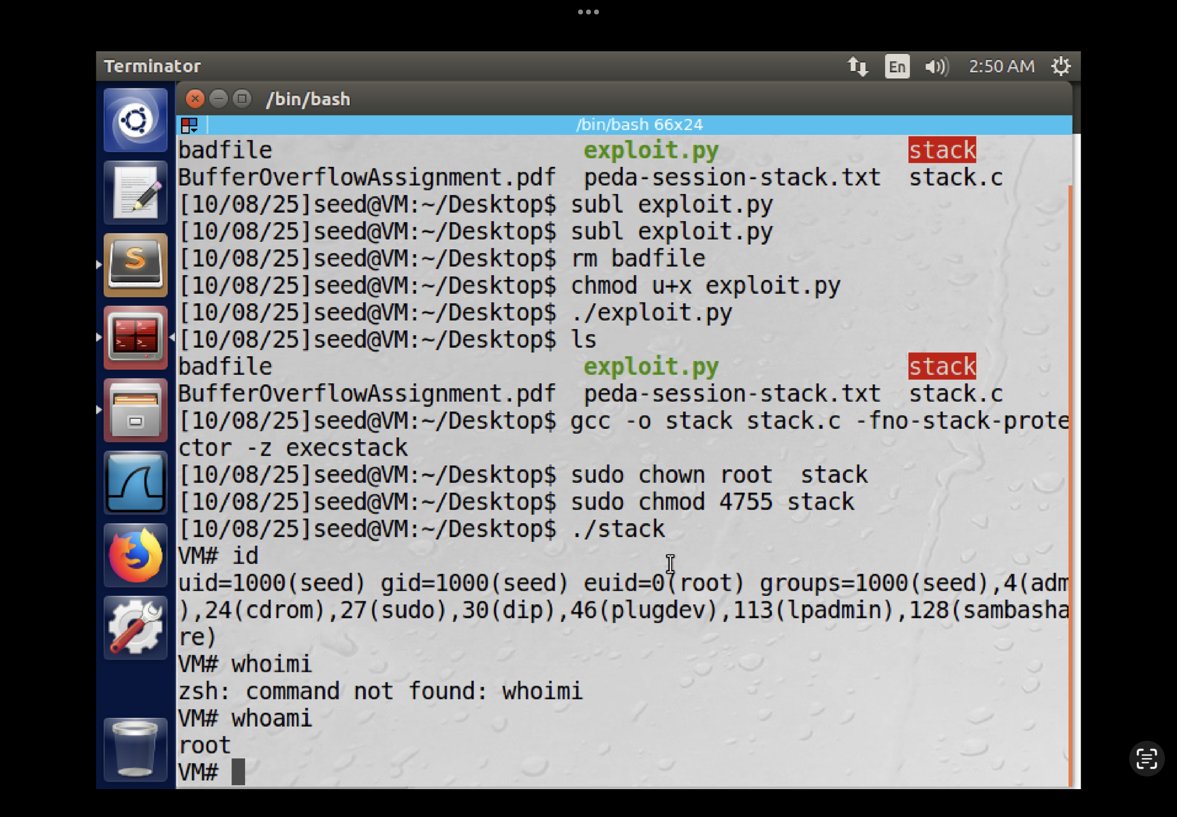
Task Three: Defeated Address Randomization

We turn randomization on to make exploitation harder + Compiled and gave the permissions

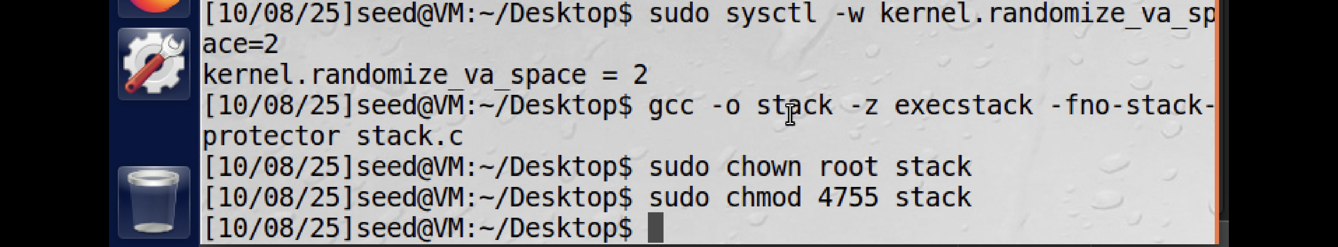

Run the def random
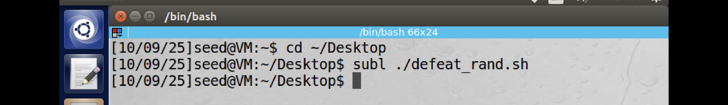

This code runs an infinite loop that increments a counter and prints elapsed time and how many attempts have run.
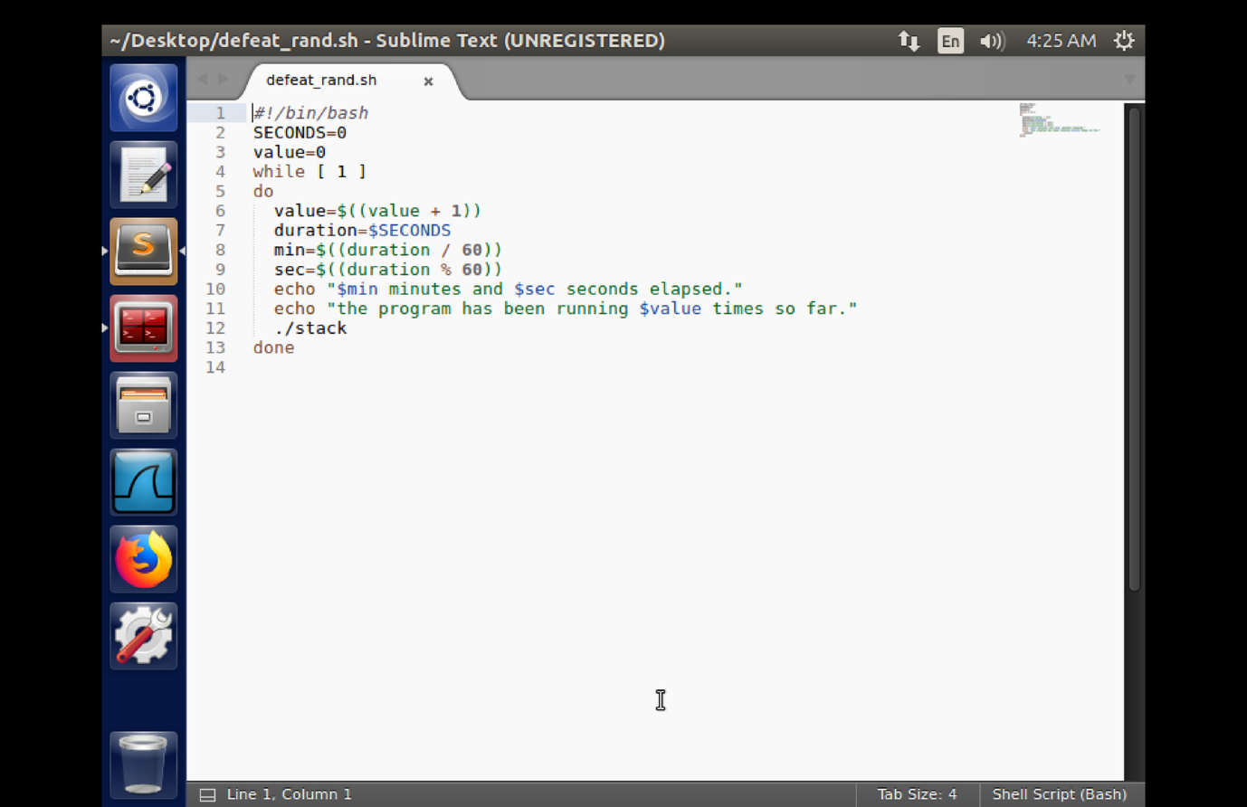

Repeated segmentation faults observed took around 25 minutes and 35 seconds.

